Name
Postal address (to which to send your training manual)
Organisation/ workplace
Email
Second Email
Phone
Do you work with kids/ adults/ both?
Profession and Academic Qualifications (e.g. psychiatrist, psychologist, psychotherapist, counsellor and degree)
Professional Body & registration number (if applicable)
Summary of experience of using specific psychological therapies (2-3 sentences)
Dietary requirements ( in-person training only)
Payment - whom should the invoice be addressed to?
I have read and agree to the Terms* | Signature ___________________

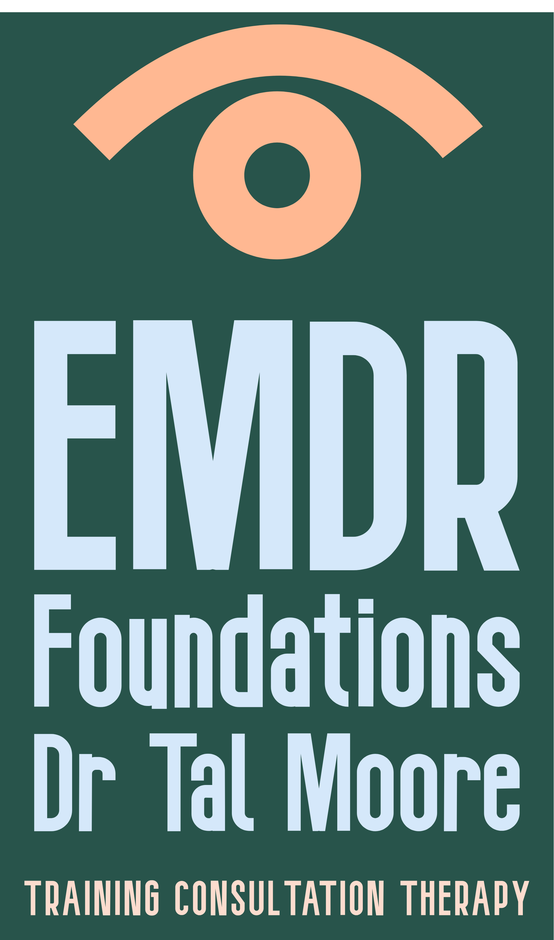
* Terms - Requests to postpone an existing registration to a later training date must be received in writing at least 30 days prior to the original training date. If such requests are made during the 30 days prior to the date of the training, then 50% of the training fee is charged, plus the cost of a new registration to the later date. Should you wish to cancel your registration an administration charge of $99 (Incl. GST) will be made for cancellations received in writing up to 30 days prior to the training. Refunds cannot be offered to cancellations received within 30 days of the training. If a participant does not attend the training there will be no refunds. In the event that EMDR Foundations cancels an event then a full refund will be made available. If you are planning to take a flight in order to attend the training, do consider taking travel insurance and consider alternative travel options in case of flight cancellations. In-person trainings do not have a remote attendance option and must be attended for the full three days.

EMDR Basic Training : Registration form

Email the completed form to drtalhmoore@gmail.com

Page 2 : Choosing your EMDR Basic Training dates

Please chose an EMDR Basic Training Part 1 and a Part 2 course. For each course you also need to chose a case consultation group from the 3 available dates.

Part 1  Online  18-20 March 2026  Wednesday-Friday  8:30am-5pm on all 3 days  Part 1 Consultation group  On Zoom, 9am-3pm  Choose one group date to attend:  - Tuesday 9 June 2026  - Tuesday 30 June 2026  - Tuesday 21 July 2026 | Part 2  Wellington  At the Pataka Gallery, Porirua  16-18 Nov 2026  Monday - Wednesday  8:30am-5pm on all 3 days  Part 2 Consultation group  On Zoom, 9am-3pm  Choose one group date to attend:  - Tuesday 2 Feb 2027  - Tuesday 23 Feb 2027  - Monday 15 March 2027
Part 1  Wellington  At the Pataka Gallery, Porirua  6-8 May 2026  Wednesday-Friday  8:30am-5pm on all 3 days  Part 1 Consultation group  On Zoom, 9am-3pm  Choose one group date to attend:  - Monday 17 August 2026  - Tuesday 8 September 2026  - Monday 19 October 2026 | Part 2  Online  15-17 Feb 2027  Monday - Wednesday  8:30am-5pm on all 3 days  Part 2 Consultation group  On Zoom, 9am-3pm  Choose one group date to attend:  - Tuesday 13 April 2027  - Monday 10 May 2027  - Tuesday 1 June 2027

EMDR Basic Training - additional information:
Your registration is for the whole course.

You will need to attend every part of the training to receive the Certificate of Completion of the Basic Training.

The cost of the entire basic training (Parts 1+2 courses, and two 5-hour case consultation groups) is $2,900 (GST incl.).

You need to have access to clients with whom you can use EMDR, as it is a requirement for the course that you practice in between the different parts.

It is highly recommended that participants arrange ongoing EMDR supervision individually or as part of a group, in addition to the 5-hour Group Case Consultations. For a list of EMDR-NZ approved case consultants and consultants in training, see https://www.emdr.org.nz/case-consultants

