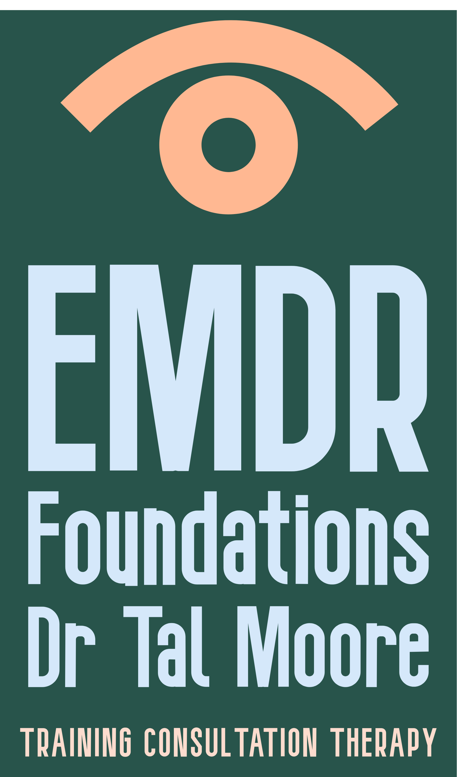

EMDR Basic Training : Registration form

** Please complete both pages and email the completed form back to [drtalhmoore@gmail.com](mailto:drtalhmoore@gmail.com). You should receive an email reply confirming your registration soon.

|  |  |
| --- | --- |
| Name |  |
| Postal address (to which to send your training manual) |  |
| Organisation/ workplace |  |
| Email |  |
| Second Email |  |
| Phone |  |
| Do you work with kids, adults, or both? |  |
| Profession and Academic Qualifications  (e.g. psychiatrist, psychologist, psychotherapist, counsellor and degree) |  |
| Professional Body & registration number (if applicable) |  |
| Summary of experience of using specific psychological therapies 2-3 sentences will be sufficient |  |
| Dietary requirements  (for in-person training only) |  |
| Payment - whom should the invoice be addressed to? |  |

EMDR 2025 dates for Basic Training and Group Case Consultation

You need to **choose one option in each row** (ie, one Part 1 course, one First Group, one Part 2 course, and one Second Group):

|  |  |  |  |  |  |  |
| --- | --- | --- | --- | --- | --- | --- |
| **Part 1**:  3 days | **Auckland**  Parnell Hotel  in-person  April 9-11, 2025  8:30am-5pm on all 3 days | | | **Wellington**  Pataka Museum Porirua  in-person  May 21-23, 2025  8:30am-5pm on all 3 days | | |
| **First Group** Case Consultation 9am-3pm  on Zoom | 13May 2025 | 27 May 2025 | 10June 2025 | 24 June  2025 | 2 July 2025 | 15 July 2025 |
| **Part 2**:  3 days | **Online-only**  September 17-19, 2025  8:30am-5pm on all 3 days | | | **Online-only**  October 15-17, 2025  8:30am-5pm on all 3 days | | |
| **Second Group** Case Consultation 9am-3pm  on Zoom | 29 Oct  2025 | 4 Nov  2025 | 12 Nov  2025 | 18 Nov  2025 | 26Nov 2025 | 9 Dec  2025 |

Your registration is for the whole course.

You will need to attend every part of the training to receive the Certificate of Completion of the Basic Training.

The cost of the entire basic training (Parts 1+2 courses, and two 5-hour case consultation groups) is $2,900 (GST incl.).

You need to have access to clients with whom you can use EMDR, as it is a requirement for the course that you practice in between the different parts.

It is highly recommended that participants arrange ongoing EMDR supervision individually or as part of a group, in addition to the 5-hour Group Case Consultations. For a list of EMDR-NZ approved case consultants and consultants in training, see <https://www.emdr.org.nz/case-consultants>