|  |  |
| --- | --- |
| Name |  |
| Postal address (to which to send your training manual) |  |
| Organisation/ workplace |  |
| Email |  |
| Second Email |  |
| Phone |  |
| Do you work with kids/ adults/ both? |  |
| Profession and Academic Qualifications (e.g. psychiatrist, psychologist, psychotherapist, counsellor and degree) |  |
| Professional Body & registration number (if applicable) |  |
| Summary of experience of using specific psychological therapies (2-3 sentences) |  |
| Dietary requirements ( in-person training only) |  |
| Payment - whom should the invoice be addressed to? |  |
| I have read and agree to the Terms* | Signature ___________________ |

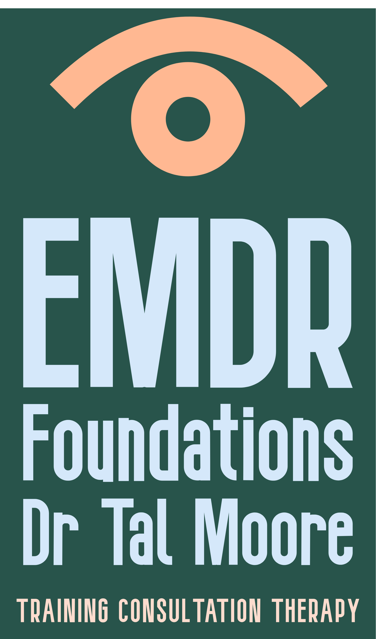* Terms - Requests to postpone an existing registration to a later training date must be received in writing at least 30 days prior to the original training date. If such requests are made during the 30 days prior to the date of the training, then 50% of the training fee is charged, plus the cost of a new registration to the later date. Should you wish to cancel your registration an administration charge of $99 (Incl. GST) will be made for cancellations received in writing up to 30 days prior to the training. Refunds cannot be offered to cancellations received within 30 days of the training. If a participant does not attend the training there will be no refunds. In the event that EMDR Foundations cancels an event then a full refund will be made available.  If you are planning to take a flight in order to attend the training, do consider taking travel insurance and consider alternative travel options in case of flight cancellations. In-person trainings do not have a remote attendance option and must be attended for the full three days.

**EMDR Basic Training : Registration form**

Email the completed form to [drtalhmoore@gmail.com](mailto:drtalhmoore@gmail.com)

**Page 2 : Choosing your training dates**

Please indicate if you wish to attend the **Auckland** *or* **Wellington** training cohort:

|  |  |
| --- | --- |
| **Online**  **Part 1 EMDR Course**  May 8-10, 2025  8:30am-5pm on all 3 days | **Wellington**  **Part 1 EMDR Course**  At the Pataka Museum Porirua, in-person  July 21-23, 2025  8:30am-5pm on all 3 days |
| **Part 1 case consultation group**  on Zoom, 9am-3pm  Choose one group date to attend:   1. Saturday 24th May 2. Tuesday 15th July 3. Monday 29th July   *I am choosing the case consultation group on _____________________* | **Part 1 case consultation group**  on Zoom, 9am-3pm  Choose one group date to attend:   1. Monday 8th September 2. Thursday 25th September 3. Thursday 9th October   *I am choosing the case consultation group on _____________________* |
| **Part 2 EMDR Course**  **Online**  September 17-19, 2025  8:30am-5pm on all 3 days | **Part 2 EMDR Course**  **Online**  February 18-20 2026  8:30am-5pm on all 3 days |
| **Part 2 case consultation group**  on Zoom, 9am-3pm  Choose one group date to attend:   1. Wednesday 22nd October 2. Tuesday 18th November 3. Saturday 22nd November   *I am choosing the case consultation group on _____________________* | **Part 2 case consultation group 2026**  on Zoom, 9am-3pm  Choose one group date to attend:   1. Monday 6th April 2026 2. Thursday 30th April 2026 3. Monday 11th May 2026   *I am choosing the case consultation group on _____________________* |

EMDR Basic Training - additional information:

Your registration is for the whole course.

You will need to attend every part of the training to receive the Certificate of Completion of the Basic Training.

The cost of the entire basic training (Parts 1+2 courses, and two 5-hour case consultation groups) is $2,900 (GST incl.).

You need to have access to clients with whom you can use EMDR, as it is a requirement for the course that you practice in between the different parts.

It is highly recommended that participants arrange ongoing EMDR supervision individually or as part of a group, in addition to the 5-hour Group Case Consultations. For a list of EMDR-NZ approved case consultants and consultants in training, see <https://www.emdr.org.nz/case-consultants>